CONNEXT: DIAMONDS

Background information

For professionals
These game challenges have been developed by Belgian, Finnish and Swedish partners of CONNEXT for inclusion project. It is not a traditional game as such, but a set of game challenges instead. Their aim is to present the project, its partners and their diverse work in a playful way. You are welcome to copy the game challenges and modify them to your own purposes.
Other game challenges in English can be found at www.metropolia.fi/games-seriously.
For further information on the CONNEXT project, please see www.connextforinclusion.eu.

Orientation to players
Welcome to get acquainted with CONNEXT for inclusion project while carrying out game challenges!

Background picture of the game
Pixabay/Colin Behrens What is important to you?

Group photo!
Usually games are played together with others in a group, which is educational and fun! As we now play alone from a distance, let us get started by having a look at group photos below. They were taken by summer workers of YMCA Helsinki during their game, which introduced them to the organisation and other summer workers.
To get points for this task: Choose your favourite group photo among the alternatives by ticking a box!
P.S. If you do ask participants to take an identifiable photo during a game, please make sure you have a written permission from them to do so.
Your first game task is completed! It's easy, isn't it?

CONNEXT quiz
Games can be used for example to check the knowledge level of participants. What do you know about CONNEXT for inclusion project?
Psst! If you don’t know the answer, you are welcome to check out our website at www.connextforinclusion.eu.

To get points for this task: Tick the option, which is NOT CORRECT.
- QUESTION 1. Which of the following countries is not a partner in CONNEXT?
  - Belgium
  - Finland
  - Norway
  - Sweden
- QUESTION 2. Which of the following is not an aim of CONNEXT?
  - Share international experiences within Europe
  - Use games to support paths towards education and labour market
  - Stregthen the technical skills of youngsters
  - Support the integration of migrants
- QUESTION 3. Which of the following don't belong to the target group of CONNEXT?
  - Professionals working in school environments
  - Professionals promoting the labour market integration of refugees and migrants
  - Newcomers and migrants themselves
  - Pensioners
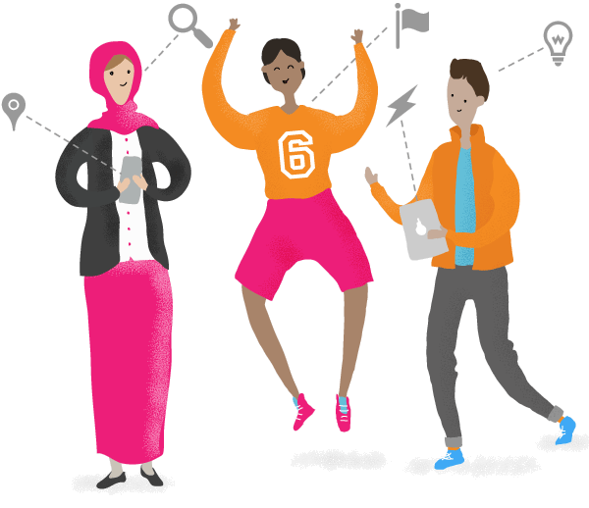

Skillful you!
One of the aims of CONNEXT is to support migrants to get closer to the labour market. CONNEXT Sweden has helped individuals to do so for example by developing #Work Sweden game, which increases knowledge about the labour market and encourages to bravely look for a job. This task helps all of us to know our strengths better.
First watch the video (1:52) on hard and soft skills by GCFLearnFree.org on YouTube. Then think for a moment what your own hard and soft skills are.
To get points for this task: Choose below 3 of the strongest soft skills you feel you have.
- Communication
- Teamwork
- Adaptability
- Problem-solving
- Creativity
- Work ethic
- Interpersonal skills
- Time management
- Leadership
- Attention to detail
- Something else
Skillfull you! Thank you for your answer.
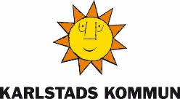

Gender glasses
(This task was carried out with a Zoom connection, which is not available after 26 Aug 2020, but you can do it even without.)
CONNEXT project together with its partners develops transnationally gender sensitive councelling material for youngsters and professionals, including game tasks.
Anniina from Girl’s House invites you to use your imaginary "gender glasses" and discuss your observations with her in Zoom.
To get points for this task: Please look around you right now. Think what elements in your surroundings are perhaps connected in a stereotypical way with certain genders. Take a photo of one of the examples and save it here. Write a short explanation how does your picture link with gender.
Well done!

Beat the coach
In CONNEXT Finland games have been used to promote wellbeing through physical exercise during lockdown in teaching and in general.
Watch how YMCA Helsinki coach Dries makes 38 movements in 30 seconds on this film.
X
To get points for this task: Make a short film of yourself doing the same excercise Dries does and insert the video here. (Please make sure that faces aren't shown as we don't have a written permission from you.)
Do not worry, if you cannot be as fast or do as many movements as him - it's really difficult to beat the coach!
Excellent, the exercise is completed! Do you already feel how your blood circulates better?
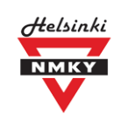

Learn some words!
Vocational college Omnia in Espoo has developed several games to support language learning. Games have been tested with migrant students and other Swedish learners.
Now it's time to test your Swedish skills! (If you don't know Swedish, you are welcome to guess or check the words online.)
To get points for this task: Match the correct Swedish words with the equivalent English words.
invandrare
immigrant
spelifiering
gamification
cocreation
samskapande
könskänslighet
gender sensitivity
integration

Migrants & gamification
CONNEXT explores how to adjust games so that they suit migrants and newcomers in particular. A handbook on lessons learnt will be availalbe in 2021.
Gaze through some CONNEXT tips from the article "Tips on game-based learning with migrants”.
To get points for this task: Think of situations, in which it would be possible or interesting to use games with migrants. Write one of your ideas here.

CONNEXT recommends the following when using games with migrants:
Explain why. Although game-based learning is becoming increasingly more common, it isn’t a familiar approach to everyone. According to our experiences, some may feel it resembles too much children’s play, which may undermine the dignity of a grown-up. This can be the case particularly with some adults from migrant groups. Whatever the group, it’s important that your group knows why you are playing the game, how does it promote the aims of the group and what do the players gain from playing.
Plan groups carefully. If the group is very heterogeneous in view of language or technical skills, it’s good to plan diverse game groups, where participants can support each other in a meaningful way. However, a special attention should be paid to the division of the labour. In some mixed CONNEXT game groups we noticed that the native speakers easily took the lead, while those from the migrant groups took a more passive role. It’s important to discuss in advance that everyone has a valuable role to play.
Keep flexible schedule. Usually everything in a game session lasts longer than you have imagined and planned. Lack of strong common language often means giving instructions takes time. They may need to be repeated a few times. In some cases cultural habits may also affect the starting time: how to make sure that everyone will be there, when the game starts?
Use oral and visual instructions. Simple game missions are a good way to start, if you are playing with a heterogeneous group. We recommend you to use plain language and to give instructions in stages. For some people listening is easier than reading. In CONNEXT we have also had good experiences with using instruction videos: if you cannot explain it, show it!
Prepare support material. In order to support your groups, you can prepare a resource pack, which can be carried e.g. in a bag and given to all groups in the beginning of the game. It can consist e.g. of a vocabulary related to the theme of the game. The support bag of Swedish #Work game consisted of a paper with a model discussion. As the participants were expected in the game to approach a stranger on the street and ask them about their career, the participants could rehearse the discussion in advance: how to start the conversation, how to explain what you aim at etc. The paper with a model discussion gave more time for the participants to prepare and increased the likelihood that the encounter is successful.
Thank you for your answer!

Help Latifa with her next step towards education or a job!
(This task was carried out with a Zoom connection, which is not available after 26 Aug 2020, but you can do it even without.)
CONNEXT is an international European Social Fund project, just like its' collaboration partner EME - Empowering Migrants for Employment. EME welcomes you to read Latifa’s story below. Then please get connected with Tea and Lilli through Zoom-platform in order discuss your answer with them.
To get points for this task: Write down here how you would advise Latifa to take steps towards education or a job.

LIFE STORY
Latifa is 36 years old. She was born in Morocco but lives now in Brussels. Latifa is divorced and takes care of her 3 children.
She has a close relationship with her sister who lives two blocks away from her. When Latifa goes to her language class, her sister takes care of her youngest son who is not yet in primary class.
Latifa did not get a lot of opportunities during her school career. She went to secondary school in Morocco but due to family circumstances she didn’t obtain her degree, which she deeply regrets. Therefore, she wants to take every chance she gets.
Latifa used to work part-time at a cleaning service and is now participating in language classes to increase her employment opportunities. However, it is not always clear for her what the possibilities are and what her next steps will be.
Exercise completed, excellent!

LockdownMinds™
CONNEXT partner GameWise in Belgium has developed a game LockdownMinds™ in English, which can be used to support the mental wellbeing of youngsters. There is also LockdownMinds™: Lockdown Edition of this game available and it can be played for free on www.sug-platform.com.
Wellbeing consists of different elements. In order to keep a good balance, we should make choices that make us feel good (selfcare factor). Often friends and family can support us (social factor). In this mini-game it is possible to explore, how you would reach a good balance through different choices.
In order to proceed in the game, you should:
- press the arrow facing down and
- swaip information boxes upwards or downwards.
Go to the mini-game: https://minigames.sug-platform.com/copingEN When you have finished playing the game, please return to this game platform.
To get points for this task: Choose one of the options below according to how helpful you feel the mini-game was in supporting you to understand different coping strategies. (5= very helpful, 1= not very helpful)
5 very helpful
4 quite a lot helpful
3 a bit helpful
2 not so helpful
1 not helpful
Exercise completed, excellent!
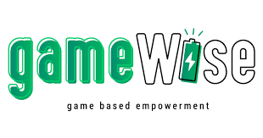

Help Mohammed!
Metropolia’s nursing students developed a game, which introduces health and well-being services in secondary schools and was tested with about 75 students at Vocational College Omnia.
Imagine the following situation:
Your friend Mohammed has been depressed for a long time and is not excited about going to school. At the same time he is hesitant to look for help, because he thinks it would show he is weak and cannot take care of himself.
Think what does a school psychologists do. Try to explain to Mohamed as a fried, why it would be good for him to use their services.
To get points for this task: Write or record (video or audio) your explanation in Seppo. If you use the video format, please make sure that faces aren't shown, as we don't have a written permission from you.
Thanks for your answer! These would be useful tips for real life students in distress.

Nature Adventure!
Vocational College Stadin ammattiopisto developed a game, in which students moved around Uutela nature park in Helsinki.
Your task is now to think what kind of places make you feel good in Finland or elsewhere. Does nature give you strength or energy?
To get points for this task: Choose one picture in your camera to show a place in nature which makes you feel good. Alternatively you can search for a picture online and insert it here.
Thank you for your answer! Keep on going!
